# File permissions in Linux

## Project description

In the project we will be using Linux commands to configure authorization of user, groups and others which is a critical concept to protect sensitive information and ensure better security for our systems.

## Check file and directory details

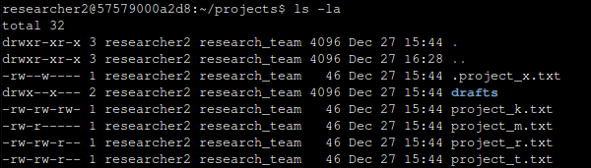

We used ls -al to list all files, directories, and hidden files permissions where -l is for listing the permissions and -a for listing hidden files.

## Describe the permissions string

For example, let's take project_k.txt permissions which is --rw-rw-r--, starting from the first 3 characters after the first one that is reserved for the type (directory or file), we see that the user has read and write permissions and the group has also read and write while the rest have only read.

## Change file permissions

Currently, the group permissions of the project_m.txt file is read only, but we want to remove that so we can do the following:

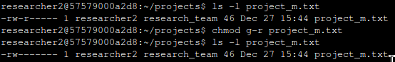

We first check for the file permissions, then we did chmod g-r project_m.txt which means change mode to [g]roup -(remove) [r]ead for the file project_m.txt, and the result is no read for group just as expected.

## Change file permissions on a hidden file

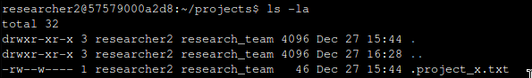

The hidden file .project_x.txt has a read and write for the user and write only for the group, but we want it to be read for user and group and remove write for both, so we want to remove the write from the user and the group, and add read to the group or in other words u-w, g-w, g+r so writing that in the chmod command gives us this:  
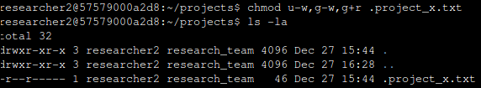

## Change directory permissions



The drafts directory has execute permission for the research_team group, and we want to remove that permission. To do this, we can simply use the command chmod g-x drafts. This command removes execute permissions from drafts directory. 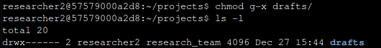

## Summary

In this project, we examined file and directory details using the ls -al command to understand permission strings. We modified file permissions for project_m.txt and the hidden file .project_x.txt using the chmod command to ensure appropriate access levels. Additionally, we adjusted directory permissions for the drafts directory to maintain security within the research_team group.